APV Method of Valuation

Application: Valuation of a company expected to be acquired through a Leverage buyout transaction
Leverage Buyout (LBO) is the acquisition by a small group of investors of a public or private company. Generally, LBO is financed primarily with debt. The new shareholders service the heavy interest and principal payments with cash from operations or asset sales. The debt levels are brought down with time. A buyout is likely to be successful only if firm generates enough cash to service debt in early years.

The Leveraged Buyout of Jay Products, Inc.
Jay Products was founded 50 years ago by Jay and originally sold snack foods such as potato chips. Through acquisitions, Jay Products has grown into a conglomerate with major divisions in snack food industry, home security systems, cosmetics and plastics. In recent years, the company has been underperforming, but the company’s management does not seem to be aggressively pursuing opportunities to improve operations (or stock price).
Megha is a financial analyst specializing in identifying potential buyout targets. She believes that two major changes are needed at Jay Products, Inc. First she thinks that the company would be better off if it sold several divisions and concentrated on its core competencies in snack foods and home security systems. Second, company is financed entirely with equity. She believes that the optimal debt to equity ratio should be at least 0.25. She believes these changes will enhance shareholder’s wealth. She also believes that the current board and the existing management are unlikely to take necessary actions. Megha thinks the company is a good candidate for a leveraged buyout.

Megha provided the following projections (in million INR): -
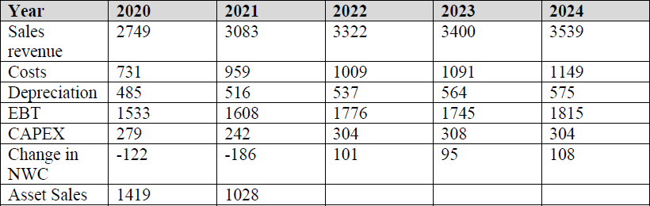

At the end of five years, she estimates that the growth rate in cash flows will be 3.5% per year. The company will also realize cash flow from sales of some of the divisions. Even though the company will sell these divisions, overall sales should increase because of more concentrated effort on the remaining divisions. She also feels that in five years, the company can be sold to another party or go public again.
The interest payments on debt for each of the next five years if the LBO is undertaken will be (in millions INR) as follows: -

The company currently has a required return on capital of 14%. The yield to maturity of the debt is 12.5% for next five years. When debt is refinanced in five years, the yield to maturity will be 8%.
Please note: For NPV of Financing effects, just consider present value of interest tax shields. Jay Products Inc. has 425 million shares outstanding that sell for INR 29 per share. The corporate tax rate is 35%.
Which method of valuation will you use and why? What is the valuation of Jay Products as of today (Year 2019)? What should be the offer per share?

